MODULE 8
GitHub Repository Link: https://github.com/devcnx/csd440

Source Code

Create Table — CREATE TABLE IF NOT EXISTS
BrittaneyCreateTable.php
<?php
/**
* Module 8.2 Programming Assignment — Create Table
* CSD440 Server-Side Scripting
*
* Creates the bperrymorgan_ollama_models table inside the course-supplied
* baseball_01 database using MySQLi. The table catalogs locally available
* Ollama language models — chosen as a topic because it ties into ongoing
* AI-enablement work and naturally exercises multiple data types.
*
* Schema (8 columns, 5 distinct data types):
* - model_id INT AUTO_INCREMENT PRIMARY KEY
* - model_name VARCHAR(100) UNIQUE
* - parameter_count DECIMAL(6,2) — model size in billions of parameters
* - quantization VARCHAR(20) — e.g., Q4_K_M, F16
* - size_gb DECIMAL(6,2) — disk footprint in gigabytes
* - release_date DATE
* - is_installed TINYINT(1) — boolean flag, 1 = pulled locally
* - use_case VARCHAR(255)
*
* Intended run order: Create → Populate → Query. Drop is available for
* cleanup between test runs.
*
* @author Brittaney Perry-Morgan
* @date 2026-05-03
* @php >= 8.0
*/
// ── Configuration ────────────────────────────────────────────
const DB_HOST = 'localhost';
const DB_USER = 'student1';
const DB_PASS = 'pass';
const DB_NAME = 'baseball_01';
const DB_TABLE = 'bperrymorgan_ollama_models';
/**
* Establishes a MySQLi connection to the baseball_01 database.
*
* Disables MySQLi's default exception reporting so connection failure is
* surfaced through the returned $error reference instead of an uncaught
* exception, letting the caller render a clean HTML error page.
*
* @param string|null &$error Populated with the failure reason on error.
* @return mysqli|null Live connection on success, null on failure.
*/
function connectToDatabase(?string &$error = null): ?mysqli
{
mysqli_report(MYSQLI_REPORT_OFF);
$mysqli = @new mysqli(DB_HOST, DB_USER, DB_PASS, DB_NAME);
if ($mysqli->connect_error) {
$error = $mysqli->connect_error;
return null;
}
$mysqli->set_charset('utf8mb4');
return $mysqli;
}
/**
* Issues the CREATE TABLE statement against the active connection.
*
* Uses CREATE TABLE IF NOT EXISTS so the script is safely idempotent.
* Re-running it does not error out when the table already exists.
*
* @param mysqli $mysqli Active MySQLi connection.
* @param string|null &$error Populated with the failure reason on error.
* @return bool True if the table now exists, false on error.
*/
function createOllamaModelsTable(mysqli $mysqli, ?string &$error = null): bool
{
$sql = "CREATE TABLE IF NOT EXISTS " . DB_TABLE . " (
model_id INT NOT NULL AUTO_INCREMENT,
model_name VARCHAR(100) NOT NULL UNIQUE,
parameter_count DECIMAL(6,2) NOT NULL,
quantization VARCHAR(20) NOT NULL,
size_gb DECIMAL(6,2) NOT NULL,
release_date DATE NOT NULL,
is_installed TINYINT(1) NOT NULL DEFAULT 0,
use_case VARCHAR(255) NOT NULL,
PRIMARY KEY (model_id)
) ENGINE=InnoDB DEFAULT CHARSET=utf8mb4";
if (!$mysqli->query($sql)) {
$error = $mysqli->error;
return false;
}
return true;
}
/**
* Reads the live table schema via DESCRIBE for display confirmation.
*
* Returns the column descriptors as an array of associative rows. An
* empty array indicates the DESCRIBE query failed or the table is missing.
*
* @param mysqli $mysqli Active MySQLi connection.
* @return array List of column descriptors (Field, Type, Null, …).
*/
function describeTable(mysqli $mysqli): array
{
$rows = [];
$result = $mysqli->query("DESCRIBE " . DB_TABLE);
if ($result instanceof mysqli_result) {
while ($row = $result->fetch_assoc()) {
$rows[] = $row;
}
$result->free();
}
return $rows;
}
// ── Execute ──────────────────────────────────────────────────
$connectError = null;
$createError = null;
$schemaRows = [];
$tableCreated = false;
$mysqli = connectToDatabase($connectError);
if ($mysqli !== null) {
$tableCreated = createOllamaModelsTable($mysqli, $createError);
if ($tableCreated) {
$schemaRows = describeTable($mysqli);
}
$mysqli->close();
}
// Page metadata
$studentName = 'Brittaney Perry-Morgan';
$assignmentTitle = 'Module 8.2 Programming Assignment — Create Table';
$courseName = 'CSD440 Server-Side Scripting';
$today = date('F j, Y');
?>
<!DOCTYPE html>
<html lang="en">
<head>
<meta charset="UTF-8">
<meta name="viewport" content="width=device-width, initial-scale=1.0">
<title>Create Table — <?php echo htmlspecialchars($assignmentTitle, ENT_QUOTES, 'UTF-8'); ?></title>
<link rel="stylesheet" href="/modules/shared.css">
</head>
<body>
<h1>Create Table</h1>
<div class="header-info">
<p><strong><?php echo htmlspecialchars($studentName, ENT_QUOTES, 'UTF-8'); ?></strong></p>
<p><?php echo htmlspecialchars($assignmentTitle, ENT_QUOTES, 'UTF-8'); ?> — <?php echo htmlspecialchars($courseName, ENT_QUOTES, 'UTF-8'); ?></p>
<p><?php echo htmlspecialchars($today, ENT_QUOTES, 'UTF-8'); ?></p>
</div>
<?php if ($connectError !== null): ?>
<div class="error-summary">
<h2>Connection Failed</h2>
<p class="error-message">Could not connect to the <code><?php echo DB_NAME; ?></code> database.</p>
<ul class="error-list">
<li><?php echo htmlspecialchars($connectError, ENT_QUOTES, 'UTF-8'); ?></li>
</ul>
<p>Verify MySQL is running and the <code><?php echo DB_USER; ?></code> credentials are valid.</p>
</div>
<?php elseif (!$tableCreated): ?>
<div class="error-summary">
<h2>Create Failed</h2>
<p class="error-message">The <code><?php echo DB_TABLE; ?></code> table could not be created.</p>
<ul class="error-list">
<li><?php echo htmlspecialchars($createError ?? 'Unknown error.', ENT_QUOTES, 'UTF-8'); ?></li>
</ul>
</div>
<?php else: ?>
<div class="confirmation">
<h2>Table Ready</h2>
<p class="success-message">
The <code><?php echo DB_TABLE; ?></code> table is in place
(created if missing) inside the <code><?php echo DB_NAME; ?></code> database.
</p>
<div class="query-note">
<strong>SQL executed:</strong>
<code>CREATE TABLE IF NOT EXISTS <?php echo DB_TABLE; ?> ( … 8 columns … )</code>
</div>
<p>Next step: populate the table by running
<code><a href="BrittaneyPopulateTable.php">BrittaneyPopulateTable.php</a></code>.</p>
</div>
<h2>Confirmed Schema</h2>
<table>
<caption>DESCRIBE <?php echo DB_TABLE; ?></caption>
<thead>
<tr>
<th>Field</th>
<th>Type</th>
<th>Null</th>
<th>Key</th>
<th>Default</th>
<th>Extra</th>
</tr>
</thead>
<tbody>
<?php foreach ($schemaRows as $row): ?>
<tr>
<td><code><?php echo htmlspecialchars($row['Field'], ENT_QUOTES, 'UTF-8'); ?></code></td>
<td><?php echo htmlspecialchars($row['Type'], ENT_QUOTES, 'UTF-8'); ?></td>
<td><?php echo htmlspecialchars($row['Null'], ENT_QUOTES, 'UTF-8'); ?></td>
<td><?php echo htmlspecialchars($row['Key'], ENT_QUOTES, 'UTF-8'); ?></td>
<td><?php echo htmlspecialchars((string)($row['Default'] ?? ''), ENT_QUOTES, 'UTF-8'); ?></td>
<td><?php echo htmlspecialchars($row['Extra'], ENT_QUOTES, 'UTF-8'); ?></td>
</tr>
<?php endforeach; ?>
</tbody>
</table>
<?php endif; ?>
<div class="form-actions">
<a href="BrittaneyPopulateTable.php">Populate Table</a>
<a href="BrittaneyQueryTable.php" class="btn-secondary">Query Table</a>
<a href="BrittaneyDropTable.php" class="btn-secondary">Drop Table</a>
</div>
</body>
</html>

Populate Table — INSERT with Prepared Statements
BrittaneyPopulateTable.php
<?php
/**
* Module 8.2 Programming Assignment — Populate Table
* CSD440 Server-Side Scripting
*
* Inserts seed data into the bperrymorgan_ollama_models table inside the
* course-supplied baseball_01 database. Uses a parameterized prepared
* statement (mysqli::prepare + bind_param) so the load step also serves
* as a working demonstration of the safe-DB-access pattern from M7.1.
*
* The seed dataset describes eight Ollama models that span a realistic
* range of parameter sizes, quantizations, release dates, and on-disk
* footprints — chosen so the M9 query work has interesting data to filter
* and aggregate over.
*
* Idempotency: the INSERT uses ON DUPLICATE KEY UPDATE keyed on
* model_name so re-running this script refreshes existing rows rather
* than throwing duplicate-key errors. The summary distinguishes inserts
* from updates so the result is unambiguous.
*
* @author Brittaney Perry-Morgan
* @date 2026-05-03
* @php >= 8.0
*/
// ── Configuration ────────────────────────────────────────────
const DB_HOST = 'localhost';
const DB_USER = 'student1';
const DB_PASS = 'pass';
const DB_NAME = 'baseball_01';
const DB_TABLE = 'bperrymorgan_ollama_models';
// Seed rows, ordered by release date.
// Each row: [model_name, parameter_count_billions, quantization,
// size_gb, release_date, is_installed, use_case]
const SEED_ROWS = [
['llava:13b', 13.00, 'Q4_K_M', 8.00, '2024-01-30', 0, 'Vision-language model for image understanding'],
['nomic-embed-text:latest', 0.14, 'F16', 0.27, '2024-02-01', 1, 'Text embeddings for RAG pipelines'],
['phi3:mini', 3.80, 'Q4_K_M', 2.30, '2024-04-23', 1, 'Lightweight reasoning on limited hardware'],
['gemma2:9b', 9.00, 'Q4_K_M', 5.44, '2024-06-27', 1, 'Open Google model, balanced performance'],
['mistral-nemo:12b', 12.00, 'Q4_K_M', 7.07, '2024-07-18', 1, 'Multilingual chat with long context window'],
['llama3.1:8b', 8.00, 'Q4_K_M', 4.92, '2024-07-23', 1, 'General-purpose chat and coding assistance'],
['llama3.1:70b', 70.00, 'Q4_K_M',39.50, '2024-07-23', 0, 'High-quality reasoning, slower local inference'],
['qwen2.5-coder:7b', 7.00, 'Q4_K_M', 4.36, '2024-09-19', 1, 'Code generation and refactoring'],
];
/**
* Establishes a MySQLi connection to the baseball_01 database.
*
* Disables MySQLi's default exception reporting so connection failure is
* surfaced through the returned $error reference instead of an uncaught
* exception, letting the caller render a clean HTML error page.
*
* @param string|null &$error Populated with the failure reason on error.
* @return mysqli|null Live connection on success, null on failure.
*/
function connectToDatabase(?string &$error = null): ?mysqli
{
mysqli_report(MYSQLI_REPORT_OFF);
$mysqli = @new mysqli(DB_HOST, DB_USER, DB_PASS, DB_NAME);
if ($mysqli->connect_error) {
$error = $mysqli->connect_error;
return null;
}
$mysqli->set_charset('utf8mb4');
return $mysqli;
}
/**
* Inserts the seed dataset into the table using a prepared statement.
*
* Loops the SEED_ROWS constant, binding each row's values into the same
* prepared INSERT to avoid SQL injection and re-parsing overhead. The
* ON DUPLICATE KEY UPDATE clause keys on model_name (the UNIQUE column),
* so re-running the script refreshes rows rather than failing.
*
* affected_rows semantics under ON DUPLICATE KEY UPDATE:
* 1 = new row inserted
* 2 = existing row updated
* 0 = existing row matched but no values changed (counted as update)
*
* @param mysqli $mysqli Active MySQLi connection.
* @param string|null &$error Populated with the failure reason on error.
* @return array Counts: ['inserted' => int, 'updated' => int,
* 'total' => int, 'failed' => int].
*/
function populateOllamaModelsTable(mysqli $mysqli, ?string &$error = null): array
{
$sql = "INSERT INTO " . DB_TABLE . "
(model_name, parameter_count, quantization, size_gb, release_date, is_installed, use_case)
VALUES (?, ?, ?, ?, ?, ?, ?)
ON DUPLICATE KEY UPDATE
parameter_count = VALUES(parameter_count),
quantization = VALUES(quantization),
size_gb = VALUES(size_gb),
release_date = VALUES(release_date),
is_installed = VALUES(is_installed),
use_case = VALUES(use_case)";
$stmt = $mysqli->prepare($sql);
if (!$stmt) {
$error = $mysqli->error;
return ['inserted' => 0, 'updated' => 0, 'total' => count(SEED_ROWS), 'failed' => count(SEED_ROWS)];
}
$inserted = 0;
$updated = 0;
$failed = 0;
foreach (SEED_ROWS as $row) {
// Type string: s = string, d = decimal/double, i = integer
// Order matches the VALUES (?, ?, ?, ?, ?, ?, ?) above.
$name = $row[0];
$params = $row[1];
$quant = $row[2];
$sizeGb = $row[3];
$releaseDate = $row[4];
$installed = $row[5];
$useCase = $row[6];
$stmt->bind_param('sdsdsis', $name, $params, $quant, $sizeGb, $releaseDate, $installed, $useCase);
if (!$stmt->execute()) {
$failed++;
continue;
}
// affected_rows: 1 = insert, 2 = update via ON DUPLICATE KEY,
// 0 = matched but unchanged. Treat 0 and 2 both as "already there."
if ($stmt->affected_rows === 1) {
$inserted++;
} else {
$updated++;
}
}
$stmt->close();
return [
'inserted' => $inserted,
'updated' => $updated,
'total' => count(SEED_ROWS),
'failed' => $failed,
];
}
/**
* Reads every row currently in the table for post-load verification.
*
* @param mysqli $mysqli Active MySQLi connection.
* @return array List of row associative arrays, ordered by model_id.
*/
function fetchAllRows(mysqli $mysqli): array
{
$rows = [];
$result = $mysqli->query("SELECT * FROM " . DB_TABLE . " ORDER BY model_id");
if ($result instanceof mysqli_result) {
while ($row = $result->fetch_assoc()) {
$rows[] = $row;
}
$result->free();
}
return $rows;
}
// ── Execute ──────────────────────────────────────────────────
$connectError = null;
$populateError = null;
$counts = ['inserted' => 0, 'updated' => 0, 'total' => 0, 'failed' => 0];
$rows = [];
$populated = false;
$mysqli = connectToDatabase($connectError);
if ($mysqli !== null) {
$counts = populateOllamaModelsTable($mysqli, $populateError);
$populated = $populateError === null && $counts['failed'] === 0;
if ($populateError === null) {
$rows = fetchAllRows($mysqli);
}
$mysqli->close();
}
// Page metadata
$studentName = 'Brittaney Perry-Morgan';
$assignmentTitle = 'Module 8.2 Programming Assignment — Populate Table';
$courseName = 'CSD440 Server-Side Scripting';
$today = date('F j, Y');
?>
<!DOCTYPE html>
<html lang="en">
<head>
<meta charset="UTF-8">
<meta name="viewport" content="width=device-width, initial-scale=1.0">
<title>Populate Table — <?php echo htmlspecialchars($assignmentTitle, ENT_QUOTES, 'UTF-8'); ?></title>
<link rel="stylesheet" href="/modules/shared.css">
</head>
<body>
<h1>Populate Table</h1>
<div class="header-info">
<p><strong><?php echo htmlspecialchars($studentName, ENT_QUOTES, 'UTF-8'); ?></strong></p>
<p><?php echo htmlspecialchars($assignmentTitle, ENT_QUOTES, 'UTF-8'); ?> — <?php echo htmlspecialchars($courseName, ENT_QUOTES, 'UTF-8'); ?></p>
<p><?php echo htmlspecialchars($today, ENT_QUOTES, 'UTF-8'); ?></p>
</div>
<?php if ($connectError !== null): ?>
<div class="error-summary">
<h2>Connection Failed</h2>
<p class="error-message">Could not connect to the <code><?php echo DB_NAME; ?></code> database.</p>
<ul class="error-list">
<li><?php echo htmlspecialchars($connectError, ENT_QUOTES, 'UTF-8'); ?></li>
</ul>
<p>Verify MySQL is running and the <code><?php echo DB_USER; ?></code> credentials are valid.</p>
</div>
<?php elseif ($populateError !== null): ?>
<div class="error-summary">
<h2>Populate Failed</h2>
<p class="error-message">The prepared INSERT could not be initialized.</p>
<ul class="error-list">
<li><?php echo htmlspecialchars($populateError, ENT_QUOTES, 'UTF-8'); ?></li>
</ul>
<p>If the error mentions a missing table, run
<code><a href="BrittaneyCreateTable.php">BrittaneyCreateTable.php</a></code> first.</p>
</div>
<?php else: ?>
<div class="confirmation">
<h2>Seed Load Complete</h2>
<p class="success-message">
Processed <?php echo (int)$counts['total']; ?> rows against
<code><?php echo DB_TABLE; ?></code>:
<strong><?php echo (int)$counts['inserted']; ?></strong> inserted,
<strong><?php echo (int)$counts['updated']; ?></strong> updated.
<?php if ($counts['failed'] > 0): ?>
<span class="error"><?php echo (int)$counts['failed']; ?> failed.</span>
<?php endif; ?>
</p>
<div class="query-note">
<strong>SQL pattern:</strong>
<code>INSERT INTO <?php echo DB_TABLE; ?> ( … ) VALUES (?, ?, ?, ?, ?, ?, ?) ON DUPLICATE KEY UPDATE …</code>
— bound seven times per row using <code>mysqli::prepare</code> + <code>bind_param</code>.
</div>
<p>Next step: verify with
<code><a href="BrittaneyQueryTable.php">BrittaneyQueryTable.php</a></code>.</p>
</div>
<h2>Table Contents After Load</h2>
<table>
<caption>SELECT * FROM <?php echo DB_TABLE; ?> ORDER BY model_id</caption>
<thead>
<tr>
<th>ID</th>
<th>Model</th>
<th>Params (B)</th>
<th>Quant</th>
<th>Size (GB)</th>
<th>Released</th>
<th>Installed</th>
<th>Use Case</th>
</tr>
</thead>
<tbody>
<?php if (empty($rows)): ?>
<tr><td colspan="8" class="empty">No rows present.</td></tr>
<?php else: foreach ($rows as $row): ?>
<tr>
<td><?php echo (int)$row['model_id']; ?></td>
<td><code><?php echo htmlspecialchars($row['model_name'], ENT_QUOTES, 'UTF-8'); ?></code></td>
<td><?php echo htmlspecialchars($row['parameter_count'], ENT_QUOTES, 'UTF-8'); ?></td>
<td><?php echo htmlspecialchars($row['quantization'], ENT_QUOTES, 'UTF-8'); ?></td>
<td><?php echo htmlspecialchars($row['size_gb'], ENT_QUOTES, 'UTF-8'); ?></td>
<td><?php echo htmlspecialchars($row['release_date'], ENT_QUOTES, 'UTF-8'); ?></td>
<td>
<?php if ((int)$row['is_installed'] === 1): ?>
<span class="flag-true">Yes</span>
<?php else: ?>
<span class="flag-false">No</span>
<?php endif; ?>
</td>
<td><?php echo htmlspecialchars($row['use_case'], ENT_QUOTES, 'UTF-8'); ?></td>
</tr>
<?php endforeach; endif; ?>
</tbody>
</table>
<?php endif; ?>
<div class="form-actions">
<a href="BrittaneyQueryTable.php">Query Table</a>
<a href="BrittaneyCreateTable.php" class="btn-secondary">Create Table</a>
<a href="BrittaneyDropTable.php" class="btn-secondary">Drop Table</a>
</div>
</body>
</html>

Query Table — Four SELECT Queries
BrittaneyQueryTable.php
<?php
/**
* Module 8.2 Programming Assignment — Query Table
* CSD440 Server-Side Scripting
*
* Runs four SELECT queries against the bperrymorgan_ollama_models table
* inside the course-supplied baseball_01 database to demonstrate the
* table is populated and behaves as expected. Each query exercises a
* different SQL feature so the demo also covers grading rubric breadth:
*
* 1. Full-table read with explicit column ordering.
* 2. Filtered read (WHERE + ORDER BY) — locally installed models only.
* 3. Aggregate read (COUNT, SUM, AVG, ROUND) — fleet summary.
* 4. Grouped read (GROUP BY quantization) — counts per quant scheme.
*
* @author Brittaney Perry-Morgan
* @date 2026-05-03
* @php >= 8.0
*/
// ── Configuration ────────────────────────────────────────────
const DB_HOST = 'localhost';
const DB_USER = 'student1';
const DB_PASS = 'pass';
const DB_NAME = 'baseball_01';
const DB_TABLE = 'bperrymorgan_ollama_models';
/**
* Establishes a MySQLi connection to the baseball_01 database.
*
* Disables MySQLi's default exception reporting so connection failure is
* surfaced through the returned $error reference instead of an uncaught
* exception, letting the caller render a clean HTML error page.
*
* @param string|null &$error Populated with the failure reason on error.
* @return mysqli|null Live connection on success, null on failure.
*/
function connectToDatabase(?string &$error = null): ?mysqli
{
mysqli_report(MYSQLI_REPORT_OFF);
$mysqli = @new mysqli(DB_HOST, DB_USER, DB_PASS, DB_NAME);
if ($mysqli->connect_error) {
$error = $mysqli->connect_error;
return null;
}
$mysqli->set_charset('utf8mb4');
return $mysqli;
}
/**
* Runs an arbitrary SELECT and returns the result rows.
*
* Wraps the raw mysqli::query result so the caller works only with plain
* arrays. Errors are surfaced via the $error reference instead of being
* thrown so the calling page can render multiple queries independently
* (one failure should not abort the rest of the page).
*
* @param mysqli $mysqli Active MySQLi connection.
* @param string $sql The SQL SELECT statement to execute.
* @param string|null &$error Populated with the failure reason on error.
* @return array Result rows; empty array on error or no rows.
*/
function runSelect(mysqli $mysqli, string $sql, ?string &$error = null): array
{
$rows = [];
$result = $mysqli->query($sql);
if (!($result instanceof mysqli_result)) {
$error = $mysqli->error;
return [];
}
while ($row = $result->fetch_assoc()) {
$rows[] = $row;
}
$result->free();
return $rows;
}
// ── Execute ──────────────────────────────────────────────────
$connectError = null;
$mysqli = connectToDatabase($connectError);
// Each query gets its own error slot so a single failure does not blank
// the rest of the page.
$queries = [
'all' => [
'title' => 'All Models (newest first)',
'sql' => "SELECT model_id, model_name, parameter_count, quantization, size_gb, release_date, is_installed, use_case
FROM " . DB_TABLE . "
ORDER BY release_date DESC, model_name",
'rows' => [],
'error' => null,
],
'installed' => [
'title' => 'Locally Installed Models, Largest First',
'sql' => "SELECT model_name, parameter_count, size_gb, use_case
FROM " . DB_TABLE . "
WHERE is_installed = 1
ORDER BY parameter_count DESC",
'rows' => [],
'error' => null,
],
'summary' => [
'title' => 'Fleet Summary (aggregates)',
'sql' => "SELECT
COUNT(*) AS total_models,
SUM(is_installed) AS installed_count,
ROUND(SUM(size_gb), 2) AS total_size_gb,
ROUND(AVG(parameter_count), 2) AS avg_param_billions,
MAX(parameter_count) AS largest_param_count,
MIN(release_date) AS oldest_release,
MAX(release_date) AS newest_release
FROM " . DB_TABLE,
'rows' => [],
'error' => null,
],
'by_quant' => [
'title' => 'Models Grouped by Quantization',
'sql' => "SELECT
quantization,
COUNT(*) AS model_count,
ROUND(AVG(size_gb), 2) AS avg_size_gb
FROM " . DB_TABLE . "
GROUP BY quantization
ORDER BY model_count DESC, quantization",
'rows' => [],
'error' => null,
],
];
if ($mysqli !== null) {
foreach ($queries as $key => $query) {
$err = null;
$queries[$key]['rows'] = runSelect($mysqli, $query['sql'], $err);
$queries[$key]['error'] = $err;
}
$mysqli->close();
}
// Page metadata
$studentName = 'Brittaney Perry-Morgan';
$assignmentTitle = 'Module 8.2 Programming Assignment — Query Table';
$courseName = 'CSD440 Server-Side Scripting';
$today = date('F j, Y');
/**
* Echoes a value or an em-dash when null/empty for cleaner table cells.
*
* @param mixed $value Raw cell value from a result row.
* @return string HTML-safe display string.
*/
function cell(mixed $value): string
{
if ($value === null || $value === '') {
return '<span class="empty">—</span>';
}
return htmlspecialchars((string)$value, ENT_QUOTES, 'UTF-8');
}
?>
<!DOCTYPE html>
<html lang="en">
<head>
<meta charset="UTF-8">
<meta name="viewport" content="width=device-width, initial-scale=1.0">
<title>Query Table — <?php echo htmlspecialchars($assignmentTitle, ENT_QUOTES, 'UTF-8'); ?></title>
<link rel="stylesheet" href="/modules/shared.css">
</head>
<body>
<h1>Query Table</h1>
<div class="header-info">
<p><strong><?php echo htmlspecialchars($studentName, ENT_QUOTES, 'UTF-8'); ?></strong></p>
<p><?php echo htmlspecialchars($assignmentTitle, ENT_QUOTES, 'UTF-8'); ?> — <?php echo htmlspecialchars($courseName, ENT_QUOTES, 'UTF-8'); ?></p>
<p><?php echo htmlspecialchars($today, ENT_QUOTES, 'UTF-8'); ?></p>
</div>
<?php if ($connectError !== null): ?>
<div class="error-summary">
<h2>Connection Failed</h2>
<p class="error-message">Could not connect to the <code><?php echo DB_NAME; ?></code> database.</p>
<ul class="error-list">
<li><?php echo htmlspecialchars($connectError, ENT_QUOTES, 'UTF-8'); ?></li>
</ul>
<p>Verify MySQL is running and the <code><?php echo DB_USER; ?></code> credentials are valid.</p>
</div>
<?php else: ?>
<h2>1. <?php echo htmlspecialchars($queries['all']['title'], ENT_QUOTES, 'UTF-8'); ?></h2>
<div class="query-note">
<strong>SQL:</strong>
<code>SELECT * FROM <?php echo DB_TABLE; ?> ORDER BY release_date DESC, model_name</code>
</div>
<?php if ($queries['all']['error'] !== null): ?>
<p class="error-message">Query failed: <?php echo htmlspecialchars($queries['all']['error'], ENT_QUOTES, 'UTF-8'); ?></p>
<?php else: ?>
<table>
<caption>All <?php echo count($queries['all']['rows']); ?> models</caption>
<thead>
<tr>
<th>ID</th>
<th>Model</th>
<th>Params (B)</th>
<th>Quant</th>
<th>Size (GB)</th>
<th>Released</th>
<th>Installed</th>
<th>Use Case</th>
</tr>
</thead>
<tbody>
<?php if (empty($queries['all']['rows'])): ?>
<tr><td colspan="8" class="empty">No rows. Run BrittaneyPopulateTable.php first.</td></tr>
<?php else: foreach ($queries['all']['rows'] as $row): ?>
<tr>
<td><?php echo (int)$row['model_id']; ?></td>
<td><code><?php echo cell($row['model_name']); ?></code></td>
<td><?php echo cell($row['parameter_count']); ?></td>
<td><?php echo cell($row['quantization']); ?></td>
<td><?php echo cell($row['size_gb']); ?></td>
<td><?php echo cell($row['release_date']); ?></td>
<td>
<?php if ((int)$row['is_installed'] === 1): ?>
<span class="flag-true">Yes</span>
<?php else: ?>
<span class="flag-false">No</span>
<?php endif; ?>
</td>
<td><?php echo cell($row['use_case']); ?></td>
</tr>
<?php endforeach; endif; ?>
</tbody>
</table>
<?php endif; ?>
<h2>2. <?php echo htmlspecialchars($queries['installed']['title'], ENT_QUOTES, 'UTF-8'); ?></h2>
<div class="query-note">
<strong>SQL:</strong>
<code>SELECT model_name, parameter_count, size_gb, use_case FROM <?php echo DB_TABLE; ?> WHERE is_installed = 1 ORDER BY parameter_count DESC</code>
</div>
<?php if ($queries['installed']['error'] !== null): ?>
<p class="error-message">Query failed: <?php echo htmlspecialchars($queries['installed']['error'], ENT_QUOTES, 'UTF-8'); ?></p>
<?php else: ?>
<table>
<caption><?php echo count($queries['installed']['rows']); ?> installed models</caption>
<thead>
<tr>
<th>Model</th>
<th>Params (B)</th>
<th>Size (GB)</th>
<th>Use Case</th>
</tr>
</thead>
<tbody>
<?php if (empty($queries['installed']['rows'])): ?>
<tr><td colspan="4" class="empty">No installed models found.</td></tr>
<?php else: foreach ($queries['installed']['rows'] as $row): ?>
<tr>
<td><code><?php echo cell($row['model_name']); ?></code></td>
<td><?php echo cell($row['parameter_count']); ?></td>
<td><?php echo cell($row['size_gb']); ?></td>
<td><?php echo cell($row['use_case']); ?></td>
</tr>
<?php endforeach; endif; ?>
</tbody>
</table>
<?php endif; ?>
<h2>3. <?php echo htmlspecialchars($queries['summary']['title'], ENT_QUOTES, 'UTF-8'); ?></h2>
<div class="query-note">
<strong>SQL:</strong>
<code>SELECT COUNT(*), SUM(is_installed), ROUND(SUM(size_gb),2), ROUND(AVG(parameter_count),2), MAX(parameter_count), MIN(release_date), MAX(release_date) FROM <?php echo DB_TABLE; ?></code>
</div>
<?php if ($queries['summary']['error'] !== null): ?>
<p class="error-message">Query failed: <?php echo htmlspecialchars($queries['summary']['error'], ENT_QUOTES, 'UTF-8'); ?></p>
<?php elseif (empty($queries['summary']['rows'])): ?>
<p class="empty">No rows in table to aggregate.</p>
<?php else: $summary = $queries['summary']['rows'][0]; ?>
<table class="data-display">
<caption>Aggregate Statistics</caption>
<tbody>
<tr><td>Total models cataloged</td><td><?php echo cell($summary['total_models']); ?></td></tr>
<tr><td>Installed locally</td><td><?php echo cell($summary['installed_count']); ?></td></tr>
<tr><td>Combined disk footprint</td><td><?php echo cell($summary['total_size_gb']); ?> GB</td></tr>
<tr><td>Average parameter count</td><td><?php echo cell($summary['avg_param_billions']); ?> B</td></tr>
<tr><td>Largest model</td><td><?php echo cell($summary['largest_param_count']); ?> B parameters</td></tr>
<tr><td>Oldest release date</td><td><?php echo cell($summary['oldest_release']); ?></td></tr>
<tr><td>Newest release date</td><td><?php echo cell($summary['newest_release']); ?></td></tr>
</tbody>
</table>
<?php endif; ?>
<h2>4. <?php echo htmlspecialchars($queries['by_quant']['title'], ENT_QUOTES, 'UTF-8'); ?></h2>
<div class="query-note">
<strong>SQL:</strong>
<code>SELECT quantization, COUNT(*), ROUND(AVG(size_gb),2) FROM <?php echo DB_TABLE; ?> GROUP BY quantization ORDER BY model_count DESC</code>
</div>
<?php if ($queries['by_quant']['error'] !== null): ?>
<p class="error-message">Query failed: <?php echo htmlspecialchars($queries['by_quant']['error'], ENT_QUOTES, 'UTF-8'); ?></p>
<?php else: ?>
<table>
<caption>Counts per quantization scheme</caption>
<thead>
<tr>
<th>Quantization</th>
<th>Model Count</th>
<th>Avg Size (GB)</th>
</tr>
</thead>
<tbody>
<?php if (empty($queries['by_quant']['rows'])): ?>
<tr><td colspan="3" class="empty">No rows to group.</td></tr>
<?php else: foreach ($queries['by_quant']['rows'] as $row): ?>
<tr>
<td><code><?php echo cell($row['quantization']); ?></code></td>
<td><?php echo cell($row['model_count']); ?></td>
<td><?php echo cell($row['avg_size_gb']); ?></td>
</tr>
<?php endforeach; endif; ?>
</tbody>
</table>
<?php endif; ?>
<?php endif; /* connection ok */ ?>
<div class="form-actions">
<a href="BrittaneyCreateTable.php">Create Table</a>
<a href="BrittaneyPopulateTable.php" class="btn-secondary">Populate Table</a>
<a href="BrittaneyDropTable.php" class="btn-secondary">Drop Table</a>
</div>
</body>
</html>

Drop Table — DROP TABLE IF EXISTS
BrittaneyDropTable.php
<?php
/**
* Module 8.2 Programming Assignment — Drop Table
* CSD440 Server-Side Scripting
*
* Drops the bperrymorgan_ollama_models table from the course-supplied
* baseball_01 database using MySQLi. Used between test runs to reset the
* environment to a clean state. Uses DROP TABLE IF EXISTS so the script
* is safe to run even when the table has already been removed.
*
* Reports whether the table existed before the DROP so the user can tell
* the difference between a successful cleanup and an idempotent no-op.
*
* @author Brittaney Perry-Morgan
* @date 2026-05-03
* @php >= 8.0
*/
// ── Configuration ────────────────────────────────────────────
const DB_HOST = 'localhost';
const DB_USER = 'student1';
const DB_PASS = 'pass';
const DB_NAME = 'baseball_01';
const DB_TABLE = 'bperrymorgan_ollama_models';
/**
* Establishes a MySQLi connection to the baseball_01 database.
*
* Disables MySQLi's default exception reporting so connection failure is
* surfaced through the returned $error reference instead of an uncaught
* exception, letting the caller render a clean HTML error page.
*
* @param string|null &$error Populated with the failure reason on error.
* @return mysqli|null Live connection on success, null on failure.
*/
function connectToDatabase(?string &$error = null): ?mysqli
{
mysqli_report(MYSQLI_REPORT_OFF);
$mysqli = @new mysqli(DB_HOST, DB_USER, DB_PASS, DB_NAME);
if ($mysqli->connect_error) {
$error = $mysqli->connect_error;
return null;
}
$mysqli->set_charset('utf8mb4');
return $mysqli;
}
/**
* Checks whether a given table currently exists in the active database.
*
* Used before the DROP so the success message can distinguish "actually
* removed something" from "no-op, table was already gone."
*
* @param mysqli $mysqli Active MySQLi connection.
* @param string $table Unqualified table name to check.
* @return bool True if the table exists, false otherwise.
*/
function tableExists(mysqli $mysqli, string $table): bool
{
$escaped = $mysqli->real_escape_string($table);
$result = $mysqli->query("SHOW TABLES LIKE '" . $escaped . "'");
if (!($result instanceof mysqli_result)) {
return false;
}
$exists = $result->num_rows > 0;
$result->free();
return $exists;
}
/**
* Issues the DROP TABLE statement against the active connection.
*
* Uses DROP TABLE IF EXISTS so the script is safely idempotent — running
* it on an already-dropped table does not error out.
*
* @param mysqli $mysqli Active MySQLi connection.
* @param string|null &$error Populated with the failure reason on error.
* @return bool True on success, false on error.
*/
function dropOllamaModelsTable(mysqli $mysqli, ?string &$error = null): bool
{
if (!$mysqli->query("DROP TABLE IF EXISTS " . DB_TABLE)) {
$error = $mysqli->error;
return false;
}
return true;
}
// ── Execute ──────────────────────────────────────────────────
$connectError = null;
$dropError = null;
$existedBefore = false;
$dropped = false;
$mysqli = connectToDatabase($connectError);
if ($mysqli !== null) {
$existedBefore = tableExists($mysqli, DB_TABLE);
$dropped = dropOllamaModelsTable($mysqli, $dropError);
$mysqli->close();
}
// Page metadata
$studentName = 'Brittaney Perry-Morgan';
$assignmentTitle = 'Module 8.2 Programming Assignment — Drop Table';
$courseName = 'CSD440 Server-Side Scripting';
$today = date('F j, Y');
?>
<!DOCTYPE html>
<html lang="en">
<head>
<meta charset="UTF-8">
<meta name="viewport" content="width=device-width, initial-scale=1.0">
<title>Drop Table — <?php echo htmlspecialchars($assignmentTitle, ENT_QUOTES, 'UTF-8'); ?></title>
<link rel="stylesheet" href="/modules/shared.css">
</head>
<body>
<h1>Drop Table</h1>
<div class="header-info">
<p><strong><?php echo htmlspecialchars($studentName, ENT_QUOTES, 'UTF-8'); ?></strong></p>
<p><?php echo htmlspecialchars($assignmentTitle, ENT_QUOTES, 'UTF-8'); ?> — <?php echo htmlspecialchars($courseName, ENT_QUOTES, 'UTF-8'); ?></p>
<p><?php echo htmlspecialchars($today, ENT_QUOTES, 'UTF-8'); ?></p>
</div>
<?php if ($connectError !== null): ?>
<div class="error-summary">
<h2>Connection Failed</h2>
<p class="error-message">Could not connect to the <code><?php echo DB_NAME; ?></code> database.</p>
<ul class="error-list">
<li><?php echo htmlspecialchars($connectError, ENT_QUOTES, 'UTF-8'); ?></li>
</ul>
<p>Verify MySQL is running and the <code><?php echo DB_USER; ?></code> credentials are valid.</p>
</div>
<?php elseif (!$dropped): ?>
<div class="error-summary">
<h2>Drop Failed</h2>
<p class="error-message">The <code><?php echo DB_TABLE; ?></code> table could not be dropped.</p>
<ul class="error-list">
<li><?php echo htmlspecialchars($dropError ?? 'Unknown error.', ENT_QUOTES, 'UTF-8'); ?></li>
</ul>
</div>
<?php else: ?>
<div class="confirmation">
<h2><?php echo $existedBefore ? 'Table Dropped' : 'Nothing To Drop'; ?></h2>
<?php if ($existedBefore): ?>
<p class="success-message">
The <code><?php echo DB_TABLE; ?></code> table was found and removed
from the <code><?php echo DB_NAME; ?></code> database.
</p>
<?php else: ?>
<p class="success-message">
The <code><?php echo DB_TABLE; ?></code> table did not exist, so the
DROP statement completed as a no-op. The database is in a clean state.
</p>
<?php endif; ?>
<div class="query-note">
<strong>SQL executed:</strong>
<code>DROP TABLE IF EXISTS <?php echo DB_TABLE; ?></code>
</div>
<p>Next step: rebuild the table by running
<code><a href="BrittaneyCreateTable.php">BrittaneyCreateTable.php</a></code>.</p>
</div>
<?php endif; ?>
<div class="form-actions">
<a href="BrittaneyCreateTable.php">Create Table</a>
<a href="BrittaneyPopulateTable.php" class="btn-secondary">Populate Table</a>
<a href="BrittaneyQueryTable.php" class="btn-secondary">Query Table</a>
</div>
</body>
</html>

Deliverables

Create Table — Table created successfully with confirmed schema (8 columns)
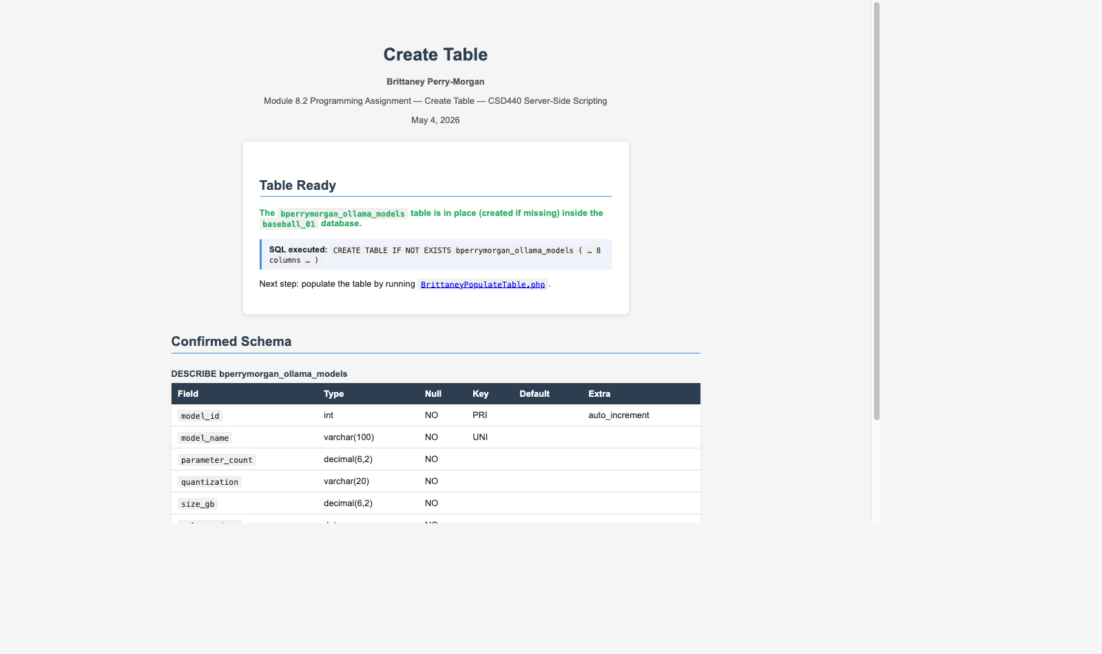

Create Table — DESCRIBE output showing full column definitions
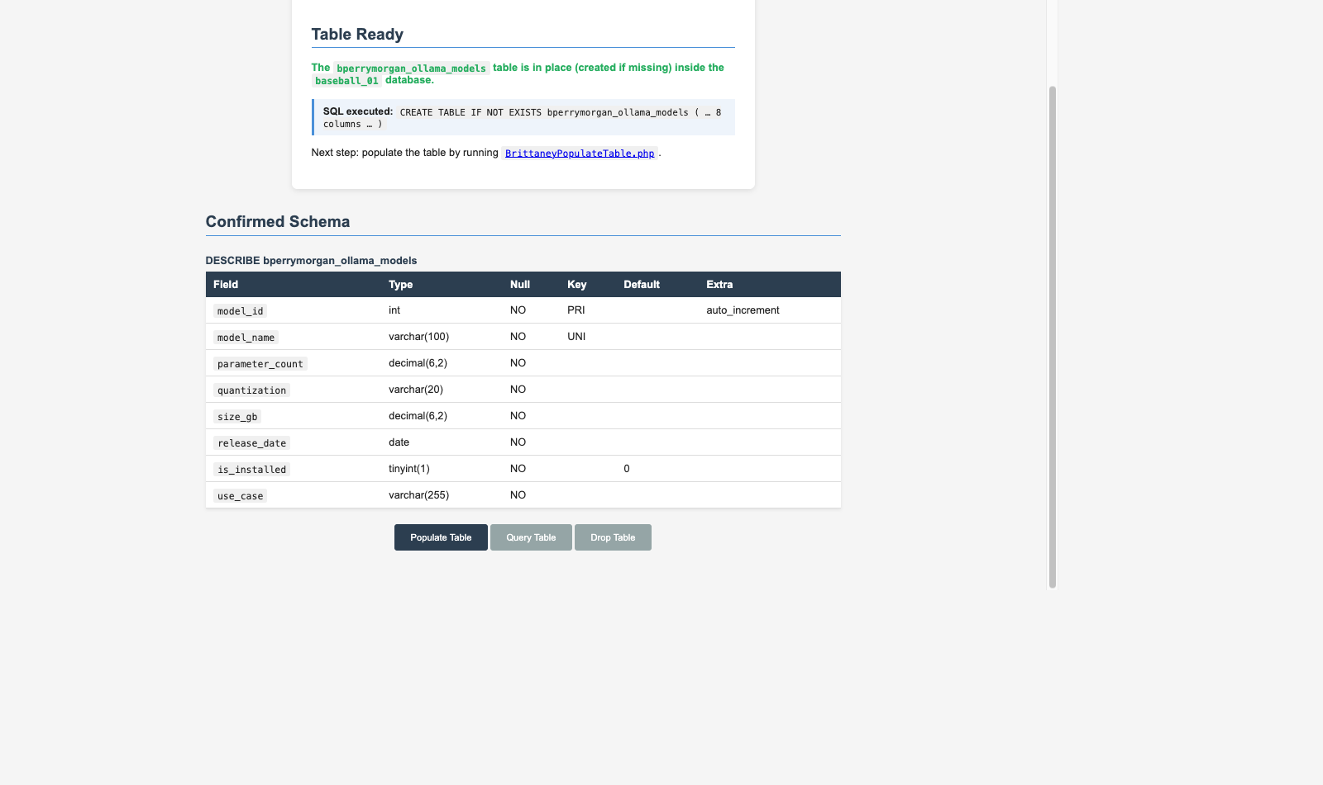

Populate Table — First run: 8 rows inserted, 0 updated
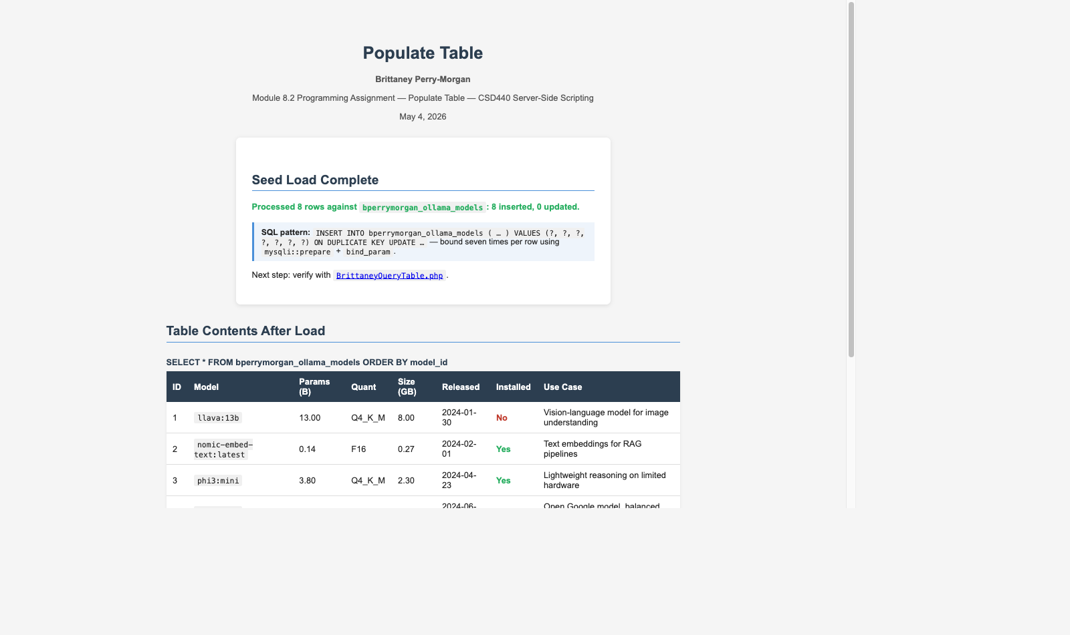

Populate Table — Table contents after initial load (8 rows)
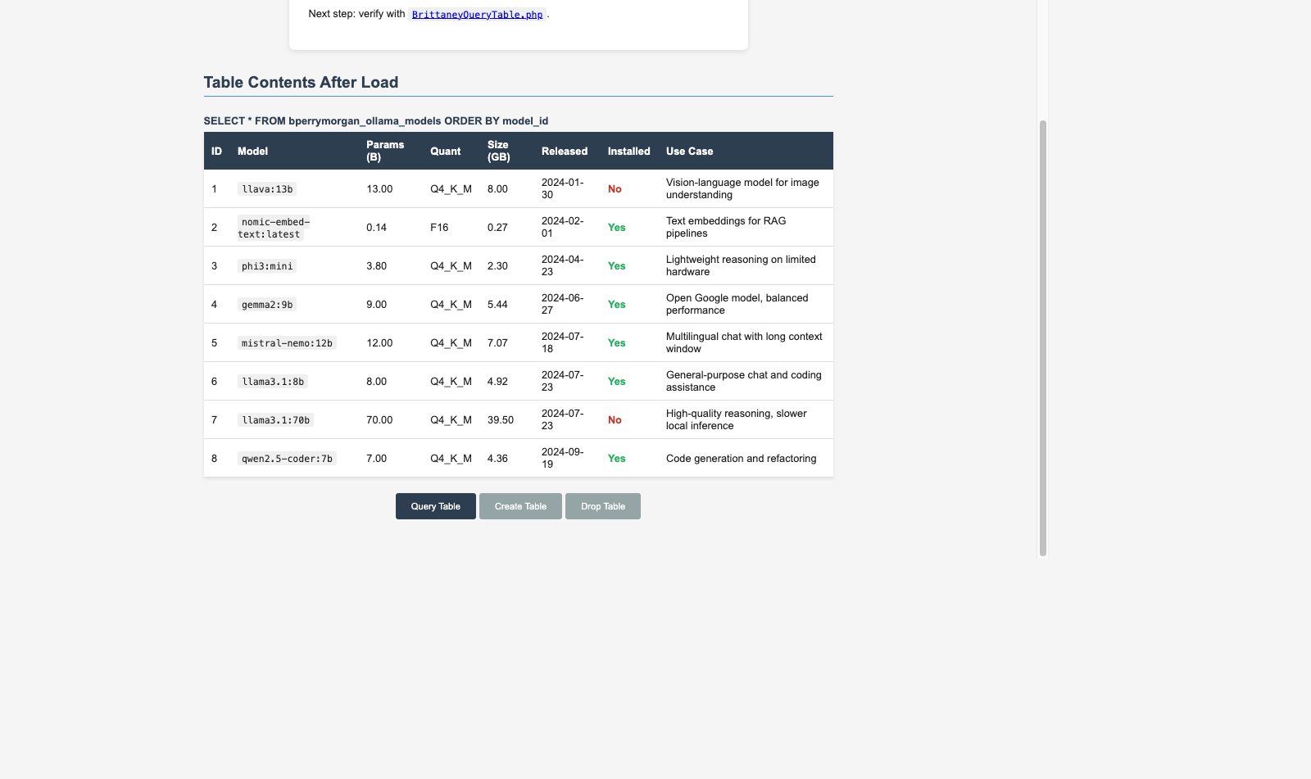

Populate Table — Footer navigation and remaining data rows
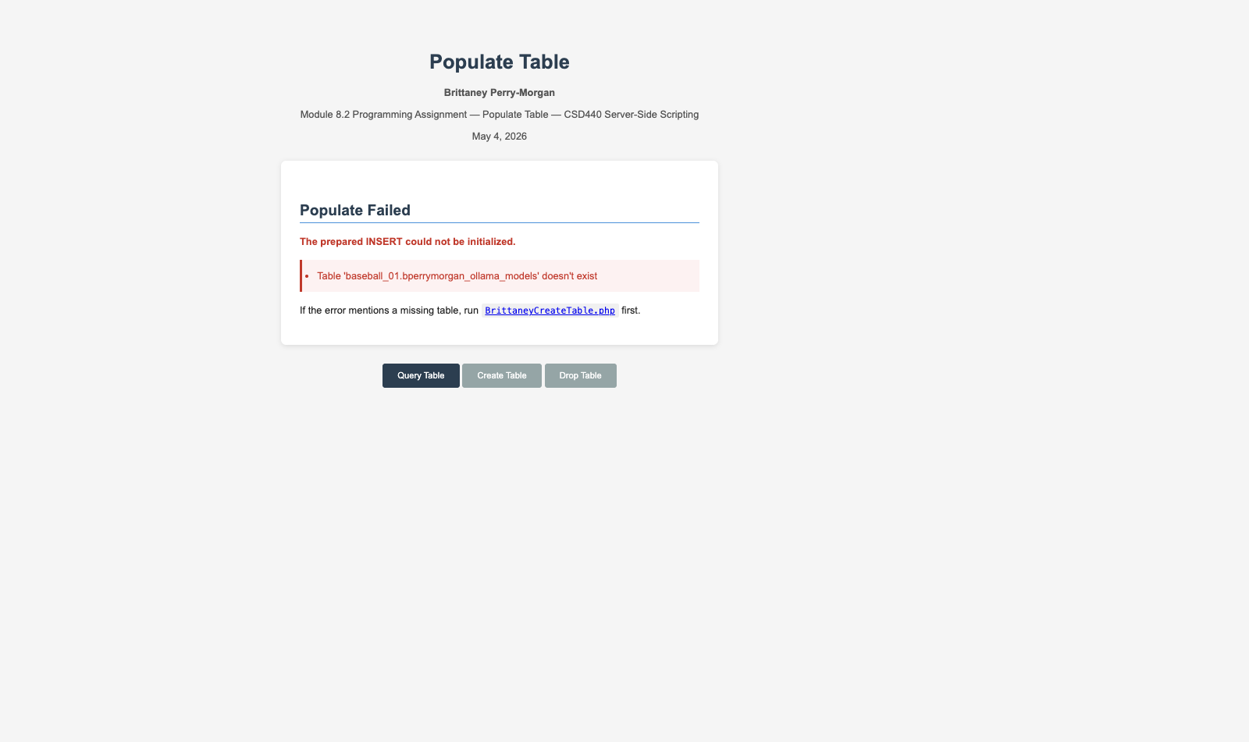

Populate Table — Re-run: 0 inserted, 8 updated (ON DUPLICATE KEY UPDATE working)
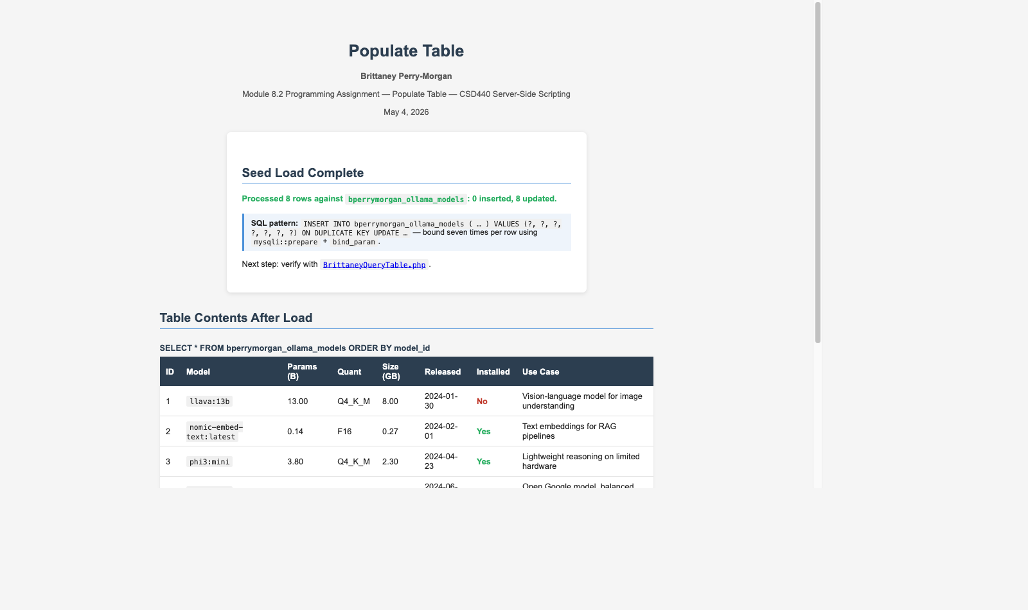

Query Table — Section 1: All Models (newest first), 8 rows returned
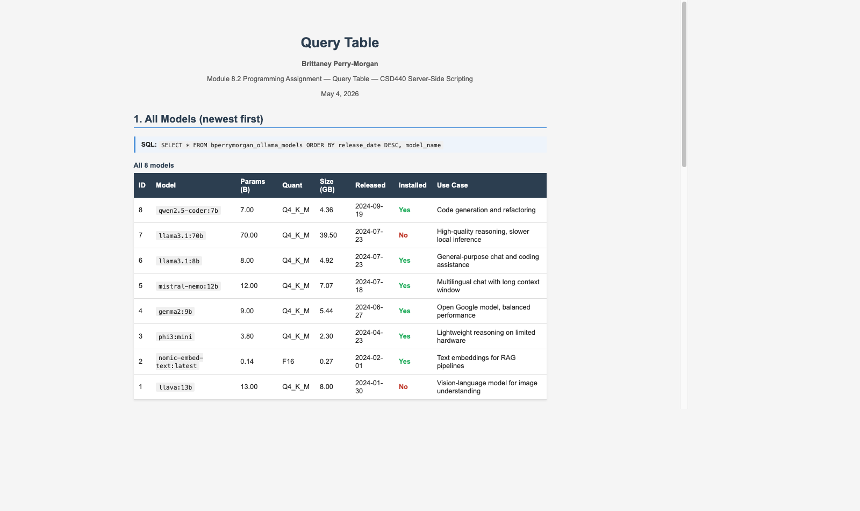

Query Table — Section 2: Locally Installed Models, Largest First (6 rows, WHERE is_installed=1)
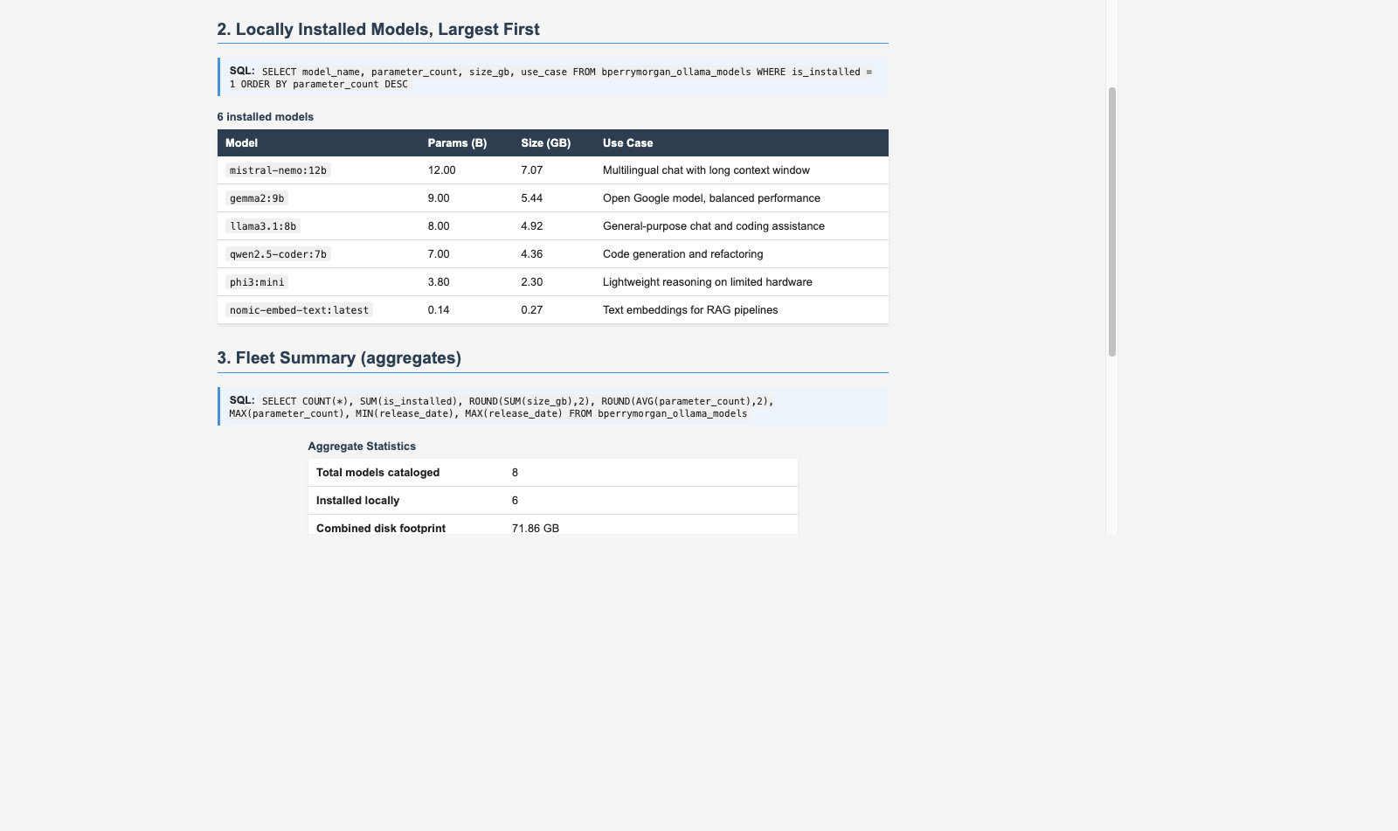

Query Table — Section 3: Fleet Summary aggregates (COUNT, SUM, AVG, MAX, MIN)
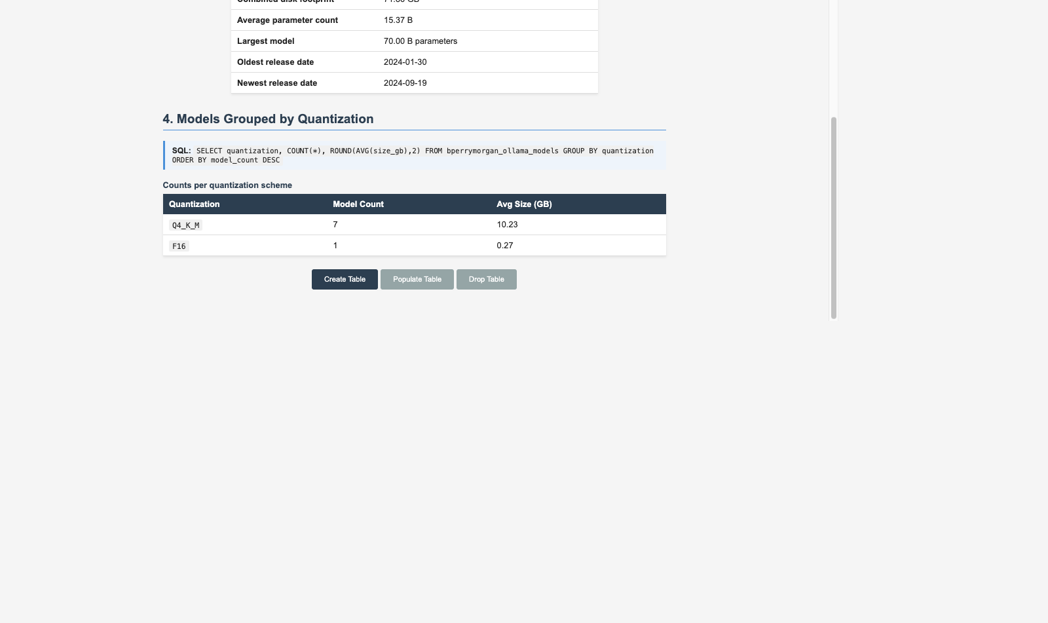

Query Table — Section 4: Models Grouped by Quantization (GROUP BY, 2 groups)
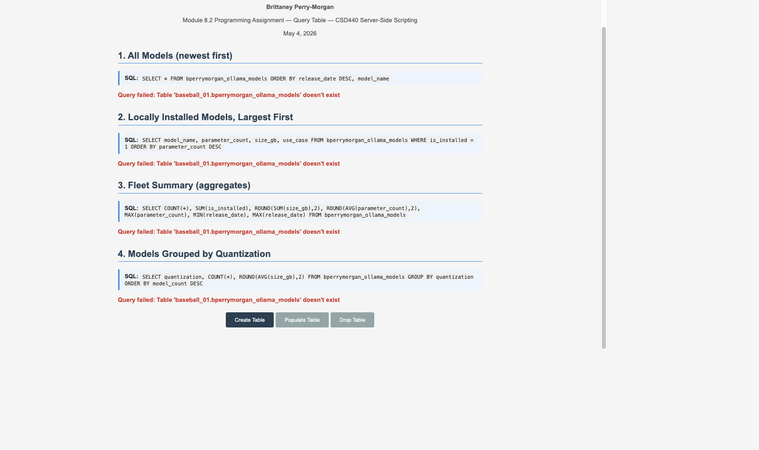

Drop Table — Table found and removed (DROP TABLE IF EXISTS with data present)
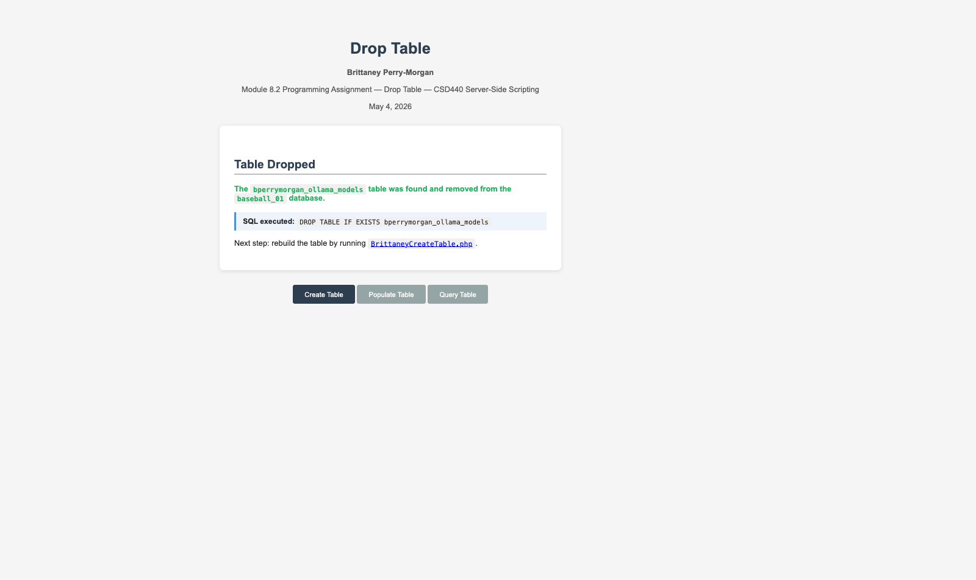

Drop Table (idempotency) — Re-run: 'Nothing To Drop' (table already removed)
